In order to take Alice’s class follow the following links:

https://online.uark.edu/courses/

When you arrive on this page, you will see the following:
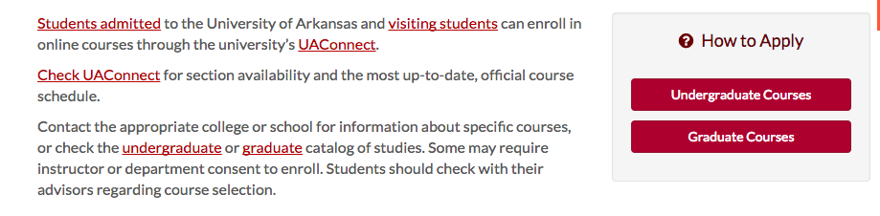
Click on the red box that says “Graduate Courses” and follow the directions for applying to take graduate classes.

After the University has allowed you to take classes, go to the following page:

https://online.uark.edu/courses/how-to-enroll.php

You will see the following:

Search for the following class;

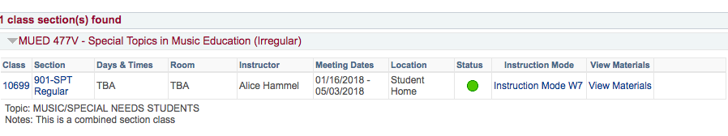

Follow the prompts to enroll.

For questions please contact:

Janet Knighten jknighte@uark.edu

